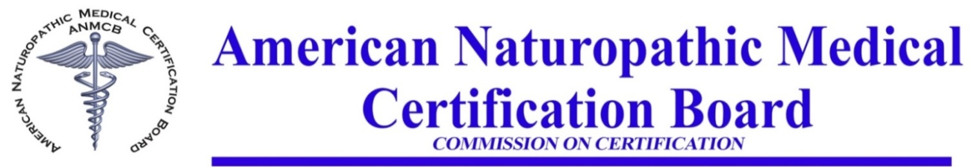

**ANMCB Exam Proctored Guidelines**

**CONTACT US FOR MORE INFORMATION:**

**7380 S. Eastern Avenue, Suite 124 Las Vegas, NV 89123**

**702 914-5770 administration@anmcb.org**

The purpose of these guidelines is to clarify the process for Board Certified Candidates in arranging proctored exams. The Board grants Candidates the opportunity to take the ANMCB Board Cer­tification Naturopathic Exam by Proctor within the US. Proctored exams may not be administered in a private residence, only in a professional proctored environment.

**Board Certification Candidate Responsibilities:**

• Submit your ANMCB Application 30 days prior to the exam date of your choice. A letter of request must be submitted with application requesting the Exam to be administered by Proctor. There is an additional $100 administrative fee, waived for Americans with Disabilities Act (ADA) Candidates. Please include your tentative exam date of choice.

• Locate a Proctor of your choice. Proctoring Services are normally available at your local Library Branch, or Community College. The Proctoring service information should be included in the letter of request with application, or provided in a timely manner. Please provide the following information:

* + - Library or Community College Name and Address
    - Proctor’s Contact Information - Name, Direct Phone Number, Email

• Make arrangements with a Proctoring Service. You will need to inform them the ANMCB Exam is given by pencil and paper, and you will need about 4.5 hours to take the exam in a timed structured proctored environment.

* Please bring your picture ID for exam check in on the scheduled day of the exam. The exam is a four-section exam with one hour allowed for each section. You will be allowed a short break in between each section. If permitted by the proctoring location, you may bring water or a drink and a snack for the break. Books and Electronic Device use is prohibited during the exam, such as cell phone, tablet, laptop, and any other electronic device. These items need to be outside of the testing area or placed in an inaccessible area during the exam.

**ANMCB Responsibilities:**

• Upon receipt of the completed ANMCB Application an ANMCB Study Guide will be mailed to you as an overview of the exam.

* ANMCB will make arrangements to have the ANMCB Exam, instructions and mailing material delivered to the Proctor’s location on the agreed upon date and confirm receipt.

• Confirm receipt of the application package back to ANMCB and present to Board for grading and review. Exam results will be mailed to you in 4 weeks.

**ANMCB Exam Preparation Options:**

The ANMCB Study Guide will be provided to you as an overview of the exam upon receipt of a complete ANMCB application. You have options to further your exam preparation by taking an ANMCB Review class. This class is not required to take the exam, rather another option in preparing for the exam.

**ANMCB** Review Preparation Course- visit our website for details- Exam Preparation Options- http://www.anmcb.org/schedule.html

**PLEASE CONTACT US FOR AVAILABLE DATES FOR EXAM PROCTORING OPTIONS**